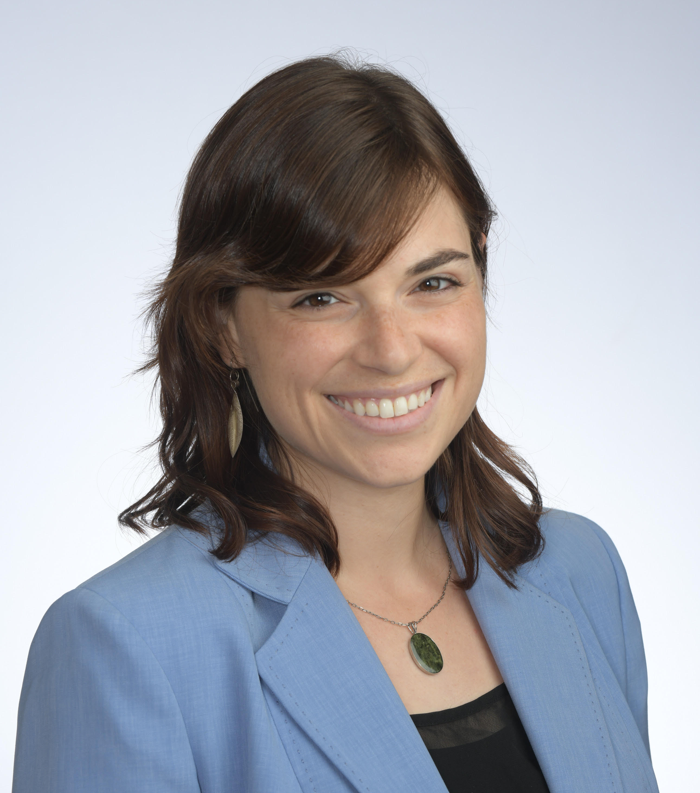
Erica Rothschild has a passion for social change work. She is currently a Social Impact MBA candidate at Boston University, specializing in strategy and organizational transformation.
After graduating Summa Cum Laude from UMass Amherst, Erica has spent nearly a decade working as a community organizer in the non-profit sector. In her career she’s worked on issues of health access, racial justice, economic justice, anti-discrimination policies, civic engagement and affordable housing. She’s had the opportunity to live abroad and work with communities in Australia, New Zealand, Israel, India, and Sweden. Like many organizers, Erica is deeply moved by the power of collective action and compelling stories. Her specialty is leadership development and she is an absolute nerd for good facilitation.
In her spare time, Erica enjoys playing trombone in a community band, sewing gifts for friends, and swimming in natural bodies of water.

